**Name : Panneerselvam N**

**Task No : 2**

**Role : Intern – Inspection**

**Date : 18/05/2021**

**Detailed study on Aerial Inspection**

Drone is used to inspect and identify defeats or faults of an industry by capturing and analysing drone data is called Aerial Inspection.

**Tools Requirements: (General : Drone , Camera , Inspector or operator)**

Tools requirements is based on what thing to be inspected.

For Example:

Power line Inspection:

For power line inspection Thermal Image Camera is additionally required to analyse heat distributions.

**Methods used in Aerial Inspection:**

**Method 1 : Off-site Inspections:**

In this method data can be collected by using Drones in Onsite and Data processing can be done in later.

**Method 2: Onsite Inspection:**

In this method both data collection and processing is done in Onsite location .

**General Tools Used:**

* Drone with Camera
* LiDAR
* GPS
* Data processing software : Dronedeploy , Pix4D

**Terms Used in Aerial Inspection:**

**Exposure station or air station:**

The position of the optical Center of the camera at the moment of exposure.

**Flying height**

The elevation of the exposure station above the datum.

**A**[**ltitude**](https://en.wikipedia.org/wiki/Altitude)

The vertical distance of the aircraft above the [Earth](https://en.wikipedia.org/wiki/Earth)'s surface.

**Tilt**

The angle between the aerial camera and the horizontal axis perpendicular to the [line of flight](https://en.wikipedia.org/wiki/Steady_flight)

**Tip**

The angle between the aerial camera and the line of flight.

**Principal point**

Geometric Center of an aerial image

**Nadir:**

The point on the aerial photograph where a plumbline dropped from the front nodal point pierces the photograph

**O**[**rthomosaic**](https://en.wikipedia.org/w/index.php?title=Orthomosaic&action=edit&redlink=1)

A high-resolution map created by orthophotos, usually via drones is termed as an orthomosaic.

**Concepts Used in Aerial Inspection :**

* Data collection – (Using UAVs)
* Data Processing – (Computer vision , Deep Learning , 3D models , Dronedeploy , Pix4D)
* Result – (Generation of inspection report like Location and type of damages )

**Tower Inspection with Drones**

A Tower is an tall structure ,taller than it’s wide and majorly used to carry something in large height.

**Types of Towers:**

**Lattice Tower:**

It is one of tower structure standing without any external support.

**Monopole Tower:**

Monopole Tower is a kind of tower that consists of one stem or one pole anchored to the ground.

**Guyed Tower:**

A guyed tower is a tall thin vertical structure that depends on guy lines for stability.

**Stealth Tower:**

A Stealth tower is disguised as tree , flagpole , church steeple and used Organization , Local areas to provide networks.

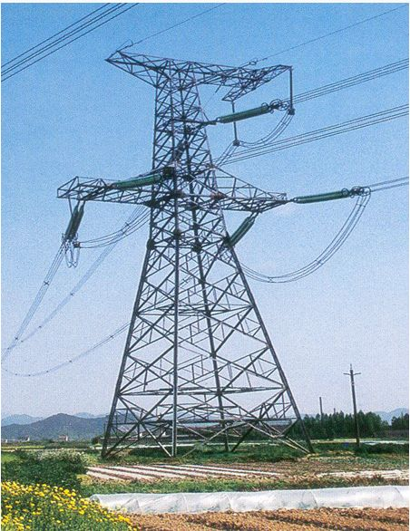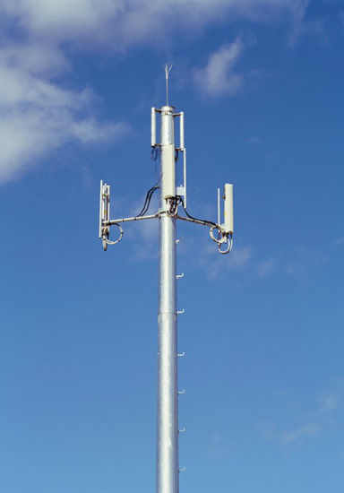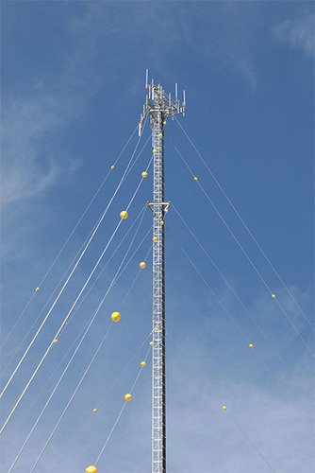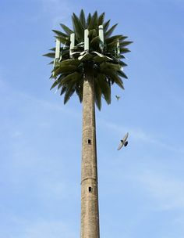

Lattice Tower

Monopole Tower

Guyed Tower

Stealth Tower

**Towers Comparisions :**

|  |  |  |  |  |
| --- | --- | --- | --- | --- |
| **Properties** | **Lattice Tower** | **Monopole Tower** | **Guyed Tower** | **Stealth Tower** |
| Maximum Height | Tokyo skyTree(634 m) | 60m | 609 m (2000 feet) | 609 m (2000 feet) |
| Additional support | No | No | Yes | No |
| Aesthetic | Medium | Good | Medium | Good |
| Application | Power Transmission, Telecom Towers,  self-radiating tower | Telecommuncation towers | Power Transmission, Telecom Towers | Local area towers , Organizations |

**Components Used in Towers**

**In Telecommunication Towers:**

1.Whip Antenna - ( Used to Receiving and Transmitting Radio signals)

2.Antenna Array – (Set of antennas used provide signal in particular directions)

3.Microwave Dish – (Special type antenna used to point to point connection)

4.Port holes - (Holes cut into the base and top of tower to allow cables and wiring to pass through the tower structure, from the base station to the antennas.)

5. Remote Radio Unit(RRU) – (Radio Wireless Transceiver)

**In Power Transmission Towers:**

1.Conductors – (Conductors are used to power transmission)

2.Insulators – (To give insulation between two conductors)

3.Fuses – (Protects from current surges)

4.Cross arm – (Support for conductor)

5. Body Extension – (Used to increase the height of towers)

6. Leg Extension – (Gives Fondmetal support for towers)

**Aerial Inspection in Tower – Use Cases :**

* Identifying Hazards – (Structural damage, Beehives , Bird nest, etc)
* Pre-work inspection - ( Use data collected via drone to determine what types of tools will be required for tower inspector to do his or her job.)
* Structural Analysis – (To find degradations in tower)

**Inspection Considerations :**

* Wind – (Wind is important factor for aerial inspections)
* Flight paths – (Set effective path for inspection)
* Electromagnetism and Distance – (Telecom towers emits powerful electro waves, so it will interrupt drone control signal. So, Maintain good distance is helpful)
* Battery Life - (Use good charged battery)